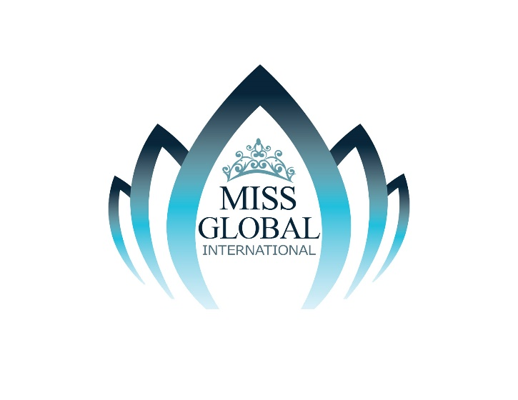

National Director

Personal Information Sheet

- Personal Information

Name:________________________________ Position : ______________________________

Company :________________________________________________________________

Address:__________________________________________________ Suite : _____________

_________________________________________________________________________

Phone: ________-_________-__________ Cell Phone : _________-_______-______

Email :____________________________________________________________________

Web Site URL :______________________________________________________________

Employer :________________________________________________________________

Address :_________________________________________________________________

City :___________________ State :_______

Position :_____________________________Phone#_____________________________

- Desired Territory

Requested Location (s) to Direct :_______________________________________________

Position: (check one) ______Local Director ______State Director

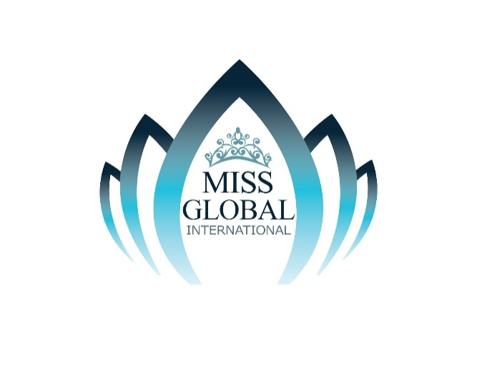

FRANCHISE AGREEMENT

This Franchise Agreement entered into on this _____ day of ______________ 20__ at Montego Bay, Jamaica by and between:
Miss Global International Pageant, Ltd. a corporation duly organized and existing under Jamaica laws, with address at P.O. Box 1366, Montego Bay, Jamaica W.I., represented herein by its President, Lachu Ramchandani, and hereinafter referred to as “_CHAIRMAN_________”
- a n d -
_,a corporation/partnership/individual of ________________, with address at ___________________________, represented herein by _______________________________, and hereinafter referred to as “National Director”or“Franchisee”

W I T N E S S E T H :

WHEREAS, Miss Global International Pageant, Ltd is the owner, organizer and producer of the Miss Global International Beauty Pageant (“Miss Global”), an international beauty competition.

WHEREAS, it is the objective of Miss Global International Pageant, Ltd. to control and maintain the quality of the candidates joining Miss Global International

WHEREAS, to achieve this objective, Miss Global International Pageant, Ltd has decided to award a franchise to an organization / corporation / partnership / individual that has the

capability and experience to organize and produce a beauty competition in their respective countries with the winner thereof being sent as the country’s representative to Miss Global International;

WHEREAS, the Franchisee has represented to Miss Global International Pageant, Ltd that it has the said capability and experience described in the preceding paragraph and has applied to Miss Global International Pageant to be the latter’s National Director in ____________________________ (Country);

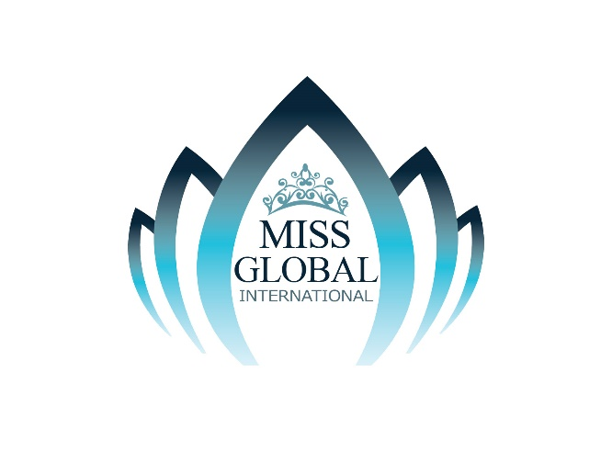

WHEREAS, Miss Global International Pageant, Ltd has accepted the Franchisee’s application to be the National Director in _________________________(Country) and will be responsible for selecting the latter’s delegate to Miss Global International;

NOW, THEREFORE, for and in consideration of the foregoing covenants and premises, Miss Global International Pageant hereby awards the franchise Global International in ___________________(Country) to the Franchisee, subject to the following terms and conditions hereinafter set forth:

- Franchisee shall organize and produce a national beauty competition on or before June 30, 2026. Only citizens can participate in the contest. It must be conducted in a fair and impartial manner, without bias or prejudice to color, race, creed, religion or ethnic origin. The Winner must be agreeable to participate in Miss Global International.

- Immediately after the National Contest, Franchisee must send to Miss Global International Pageant, Ltd by courier or facsimile the Miss Global International Entry Form properly accomplished by the Winner, including her declaration and undertaking. Said winner must arrive in the Host Country 5 days prior to the Coronation Night TBA

- Franchisee must also send to Miss Global International, Ltd on or before July 30, 2026 the following:

- B/W or Colored postcard size photograph of winner in swimsuit in “Portrait” and “Full Body Shot” poses.
- Negative/slide prints of the above photographs for publicity purposes
- Certified photocopy of your candidate’s birth certificate

- Franchisee hereby agrees that the delegate he/she sends must possess all of the following qualifications:

- Single or married
- Between 17 and 40 years of age.
- Minimum height of 5’4” (164.6cm)
- Citizen of the country she is representing.
- Good moral character
- Has not engaged in prostitution or any form thereof
- Has not participated in any obscene or x-rated exhibitions, whether print, stage, television or movies

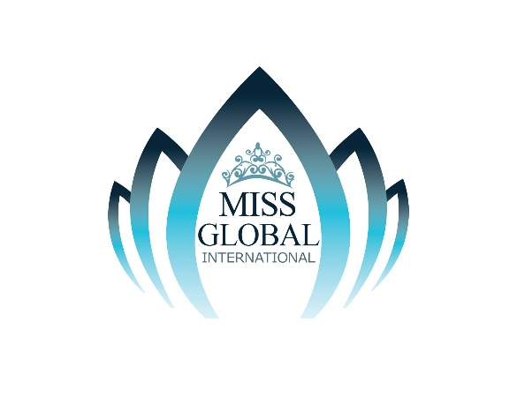
- Has not worked as a Model, Hostess or any similar capacity in establishments generally reputed to be “girlie” joints
- Has not been convicted of any crime.
- Familiarity with her country’s culture and environmental concerns/problems

- Franchisee agrees to shoulder the following expenses:
- Delegate’s round-trip airfare to Host Country, including charges for excess baggage, if any.
- Indigenous gift item worth US$100 to be auctioned for charity.
- Pocket money of at least US$ 200 to cover Delegate’s incidental expenses

- The Franchisee must make sure that his/her delegate brings the following:
- National Costume representing your Country
- Coronation Gowns and Accessories
- Swimwear (two piece or full) representing the colors of the flag of your Country (appropriate cover up/wrap optional)
- Other casual, cocktail and business wear for the duration of your stay.
- Sports wear; Gym outfit
- Shoes and accessories

- In exchange for the foregoing, Miss Global International Pageant, Ltd agrees to perform the following obligations:

- Meet the Delegate upon her arrival in Host Country @ VIP Lounge and with a stretch limousine
- Meet the queen party and arrival hosted by Miss Global International Pageant Ltd
- Provide inland transportation for the Delegates
- Provide make-up artists and hair stylists for the Delegates
- Provide backstage assistance for the Delegates
- Assure the Delegate’s safety and security
- Provide Island tour and courtesy calls
Provide Delegate five star hotel accommodation and meals during the period of the competition
- Full time Chaperone

- Miss Global International Pageant, Ltd agrees to provide the television rights to individual host country free for the first year of this Agreement providing Miss Global International will have the rights to claim a small percentage of the copy rights.

- Miss Global International Pageant, Ltd expressly reserves the right to postpone, change the venue or even cancel Miss Global for reasons of force Jamaican, government regulations or adverse economic conditions. Franchisee will however be notified of the same at least sixty (60) days prior to the scheduled Coronation Night.

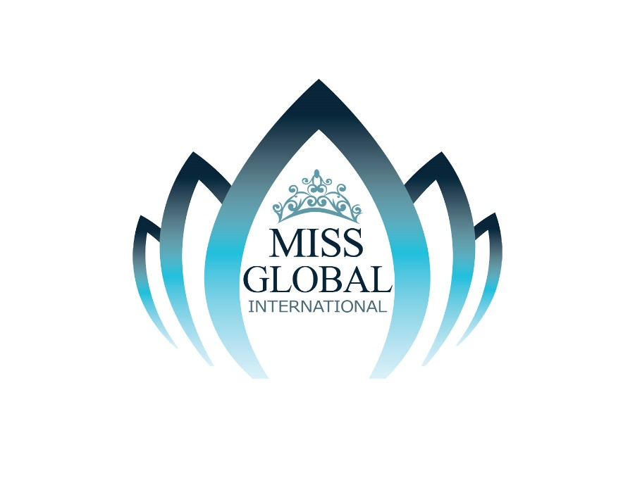
- The Franchise Fee USD$1,000 and Contestant Registration Fee is USD$500.00 and this Franchise Agreement will be valid for a period of one year starting 2026 - 2027 and will be automatically renewable every year providing Franchisee complies with his/her obligations under this Agreement. Miss Global International Pageant, Ltd may terminate this Agreement if in its sole discretion; the Franchisee has not faithfully complied with his/her commitments required under this Agreement.

- No employer/employee or principal/agent relationship exists or contemplated between Miss Global International Pageant, Ltd and Franchisee.

- This Agreement shall be deemed to have been made and executed in Jamaica and accordingly will be governed and interpreted in accordance with Jamaica laws.

IN WITNESS WHEREOF, the parties have hereunto signed their names on the space indicated below on this ______day of _______ 20

at Montego Bay, Jamaica and ____________.

MISS GLOBAL INTERNATIONAL, LTD. FRANCHISEE NAME
P.O. Box 1366, Blue Diamond Shopping Mall
By: By:

Lachman Ramchandani, OD JP __________________
President

